**Manager Performance Review and Instructional Guide**

Paycom Performance Management allows you and your employee to manage and track performance through CRISTA’s core values and competencies.

Below is an overview of the performance review and the core values and competencies that will help employees to achieve overall success. Personal goals are also available to be used in the performance review. If they are being used, the employee will enter in Paycom ESS and the manager will approve prior to HR creating the performance review. Once created, this will be visible to both the manager and employee.

Below are the manager and non-manager performance reviews as well as instructions on how to use Paycom Performance.

**Performance Reviews**

**Non-Manager Performance Review**

Values and Competencies:

* **CRISTA Values**
  + **CHRIST-CENTERED -** Approaches work by faith and prayer
  + **SERVANTHOOD** - Serves our world by meeting needs practically and spiritually
  + **UNCOMPROMISING INTEGRITY** - honest, transparent, and trustworthy
  + **HOLY STEWARDSHIP** - honors and maximizes the potential of the resources, assets, and people God has entrusted to us
  + **EXCELLENCE -** We serve with excellence, knowing we represent God in our work, words, and actions.
  + **UNIFIED TEAM –** models One CRISTA and united in the vision to transform lives with the Gospel of Jesus Christ
* **Work Quality/Quantity** *-* Delivers quality work. Is reliable, accurate and thorough. Performs appropriate amount or volume of work.
* **Job knowledge** - Has the knowledge and skills to perform the functions of the job. Consider ability, technical knowledge and skills, analytical ability, problem-solving skills and confidence of work performed.
* **Safety** - Exhibits safe work habits and is aware of safety rules. Maintains a clean work area, contributes to overall safety of the department.
* **Adaptability** - Adjusts well to a variety of situations and change; flexible.
* **Teamwork -** Builds and maintains positive, supportive working relationships. Helps accomplish team goals.
* **Communication -** Communicates in a clear, concise and courteous manner. This competency also includes verbal, written and listening skills.
* **Initiative -** Takes initiative to examine current methods. Makes useful suggestions and/or takes action for improvement.
* **Decision Making -** Makes well-reasoned, sound decisions that affect work performance.
* **Dependability -** Can be relied upon to persevere and carry through to completion any task assigned and meet deadlines. This competency also applies to attendance and punctuality.

**Manager Performance Review**

Values and Competencies:

* **Christ-centered Ministry -** Approaches work by faith and prayer. Engages in faith disciplines that reflect spiritual growth and commitment. Leadership demonstrates Fruits of the Spirit in decision making, words and actions. Provides opportunity for employees to grow spiritually and integrate their faith at work. Leads with humility and grace.
* **Servanthood -** Serves our world by meeting needs practically and spiritually. Seeks employee input with problems that affect them and implements their suggestions whenever possible. Cares for employees.
* **Uncompromising Integrity -** Honest, transparent, and trustworthy. Creates environment of ethical behavior and transparency. Builds high level of trust with employees. Models humility, fairness and integrity.
* **Holy Stewardship -** Honors and maximizes the potential of the resources, assets, and people God has entrusted to us. Develops effective strategies to help employees accomplish goals and objectives. Ensures great stewardship in all areas of responsibility. Accomplishes annual goals and objectives.
* **Excellence -** We serve with excellence, knowing we represent God in our work, words, and actions.
* **Unified Team -** Models One CRISTA and united in the vision to transform lives with the Gospel of Jesus Christ. Leads with organizational values. Creates high level of engagement by connecting employees to the mission and vision. Works together effectively as a team with other ministries and within CRISTA. Follows through on promises and commitments.
* **Talent Management** - Hires and retains top talent. Minimizes turnover. Develops strategies to help employees accomplish goals and objectives using GROW. Effectively manages employee performance using CRISTA's transformative performance management process and Paycom tools. Success with creating a culture of engagement.
* **Employee Development** - Challenges direct reports with opportunities to grow professionally and personally. Removes barriers that negatively impact performance. Rewards, develops and promotes top performers. Provides necessary resources and training. Ensures pay is equitable within the assigned salary range and department.
* **Healthy Communication** - Encourage staff to experiment, innovate and voice opinions freely. Seeks input from direct reports and others. Informs, encourages and empowers others.

Below is CRISTA’s rating scale, which will be used to rate each competency, core value and goal, if using.

**Approve Employee Personal Goals**

* First, meet with your employee and discuss their individual performance or development goals that they should be working on for the performance review period.
* In order to ensure that the employee is successful with entering goals in Paycom ESS, ask them to enter goals during your meeting (please reference Employee Performance Management Instructional Guide).
* Once the employee enters his/her goals in Paycom, you will receive an email notification that there are employee goals that need to be reviewed and approved.
* Log into Paycom.
* Hover over Talent Management in the green menu at the top of the page. Click on Performance Management.
* Then click Performance Dashboard.

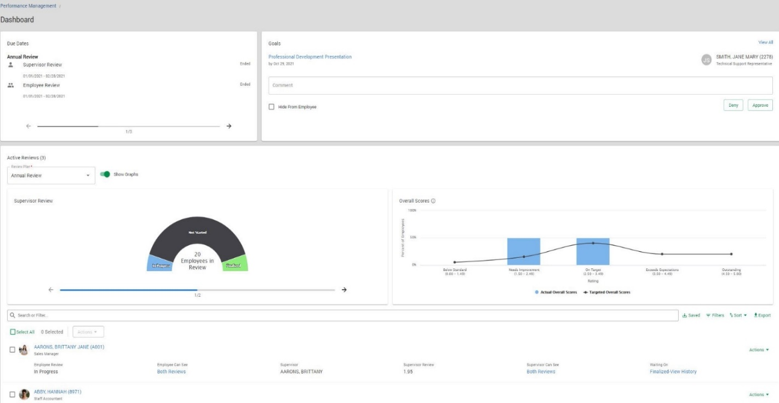

The one page view displays the following three sections:

1. Due Dates
2. Goals
3. Active Reviews
4. The Due Dates section will show when the employee and supervisor must complete their portions of the review.

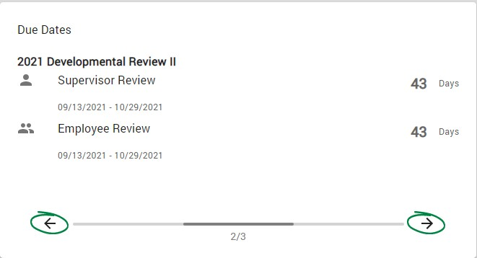

1. The Goals section displays personal goals that must be approved (or denied).

* Approve (or deny) goals from this initial page by clicking the “Deny” or “Approve” button at the bottom of the section. A comment can be entered prior to approving or denying if needed. The next goal that requires action will display for review.
* Or click “View All” at the top of the page to see all pending goals in a list format and batch approve (or deny) submitted goals.

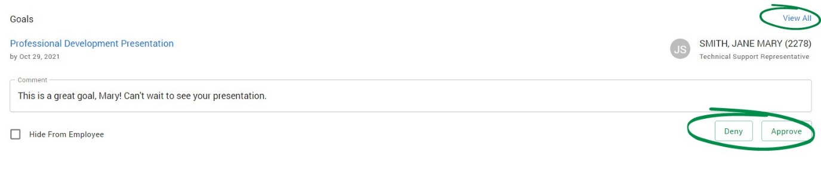

Once all your employees’ goals are entered and approved, email Heidi Knapp at [hknapp@crista.net](mailto:hknapp@crista.net), so the formal evaluation can be created.

1. The Active Reviews section displays your employees under their Review Plan. These are grouped by staff, staff with goals, manager, manager with goals and ministry council. If you have employees in more than one group, there will be a drop-down menu in the Review Plan box. You will need to select the different groups listed to see employees under those groups.

The graph on the left side of the page displays supervisor or employee progress for the selected review plan group (click the arrow under the graph to toggle between supervisor and employee progress). The graph on the right side of the page displays the scores of all finalized reviews (this will say No Overall scores to Show until reviews are finalized). To hide the graphs, click the toggle switch next to Show Graphs.

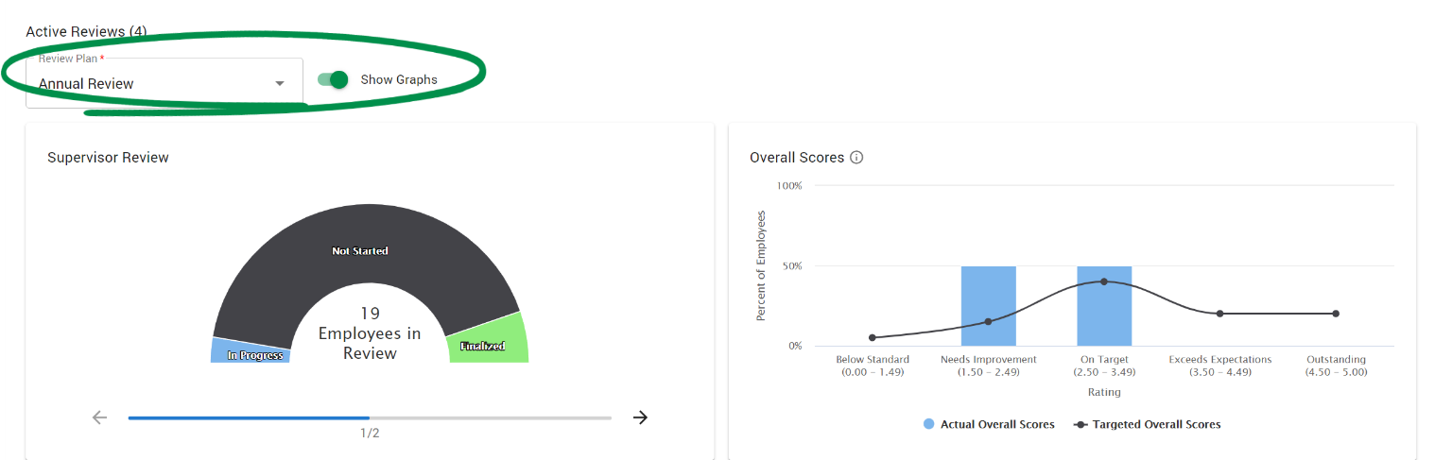

**Manage Employee Performance Reviews in Paycom**

* Once the review is created for your employees(s), they will be able to start tracking and updating their progress toward goal completions.
* To view this progress, move your cursor over Talent Management, then click on Performance Management, then click on Performance Dashboard.
* Scroll to the Active Reviews section.



* Click on any employee to view their performance evaluation and progress.
* At the end of the review period, the employee must complete their self-rating and any notes to help explain their self-evaluation.
* Once the employee submits his/her performance evaluation to you for approval, you will enter your rating of them along with accompanying comments.

Final evaluations should be forwarded to the assigned HR representative by selecting the name in the “submit to” box then clicking on “Submit.”