**Performance Management Instructional Guide - Employee**

Paycom Performance Management allows you and your manager to discuss and track your performance on CRISTA’s core values and competencies through a digital review process. Personal goals can also be included in the review process, but is at your manager’s discretion.

This guide includes:

1. Competencies and core values for staff and managers.
2. Performance review assignment.
3. Completing the performance review.
4. Adding personal goals (optional).
5. Tracking personal goals (optional).
6. **Competencies and Core Values**

**Staff Competencies and Core Values**

* **CRISTA Values**
  + **CHRIST-CENTERED -** Approaches work by faith and prayer
  + **SERVANTHOOD** - Serves our world by meeting needs practically and spiritually
  + **UNCOMPROMISING INTEGRITY** - honest, transparent, and trustworthy
  + **HOLY STEWARDSHIP** - honors and maximizes the potential of the resources, assets, and people God has entrusted to us
  + **EXCELLENCE -** We serve with excellence, knowing we represent God in our work, words, and actions.
  + **UNIFIED TEAM –** models One CRISTA and united in the vision to transform lives with the Gospel of Jesus Christ
* **Work Quality/Quantity** *-* Delivers quality work. Is reliable, accurate and thorough. Performs appropriate amount or volume of work.
* **Job knowledge** - Has the knowledge and skills to perform the functions of the job. Consider ability, technical knowledge and skills, analytical ability, problem-solving skills and confidence of work performed.
* **Safety** - Exhibits safe work habits and is aware of safety rules. Maintains a clean work area, contributes to overall safety of the department.
* **Adaptability** - Adjusts well to a variety of situations and change; flexible.
* **Teamwork -** Builds and maintains positive, supportive working relationships. Helps accomplish team goals.
* **Communication -** Communicates in a clear, concise and courteous manner. This competency also includes verbal, written and listening skills.
* **Initiative -** Takes initiative to examine current methods. Makes useful suggestions and/or takes action for improvement.
* **Decision Making -** Makes well-reasoned, sound decisions that affect work performance.
* **Dependability -** Can be relied upon to persevere and carry through to completion any task assigned and meet deadlines. This competency also applies to attendance and punctuality.

**Manager Competencies and Core Values**

* **Christ-centered Ministry -** Approaches work by faith and prayer. Engages in faith disciplines that reflect spiritual growth and commitment. Leadership demonstrates Fruits of the Spirit in decision making, words and actions. Provides opportunity for employees to grow spiritually and integrate their faith at work. Leads with humility and grace.
* **Servanthood -** Serves our world by meeting needs practically and spiritually. Seeks employee input with problems that affect them and implements their suggestions whenever possible. Cares for employees.
* **Uncompromising Integrity -** Honest, transparent, and trustworthy. Creates environment of ethical behavior and transparency. Builds high level of trust with employees. Models humility, fairness and integrity.
* **Holy Stewardship -** Honors and maximizes the potential of the resources, assets, and people God has entrusted to us. Develops effective strategies to help employees accomplish goals and objectives. Ensures great stewardship in all areas of responsibility. Accomplishes annual goals and objectives.
* **Excellence -** We serve with excellence, knowing we represent God in our work, words, and actions.
* **Unified Team -** Models One CRISTA and united in the vision to transform lives with the Gospel of Jesus Christ. Leads with organizational values. Creates high level of engagement by connecting employees to the mission and vision. Works together effectively as a team with other ministries and within CRISTA. Follows through on promises and commitments.
* **Talent Management** - Hires and retains top talent. Minimizes turnover. Develops strategies to help employees accomplish goals and objectives using GROW. Effectively manages employee performance using CRISTA's transformative performance management process and Paycom tools. Success with creating a culture of engagement.
* **Employee Development** - Challenges direct reports with opportunities to grow professionally and personally. Removes barriers that negatively impact performance. Rewards, develops and promotes top performers. Provides necessary resources and training. Ensures pay is equitable within the assigned salary range and department.
* **Healthy Communication** - Encourage staff to experiment, innovate and voice opinions freely. Seeks input from direct reports and others. Informs, encourages and empowers others.

Below is CRISTA’s scale, which will be used to rate each competency and core value.

1. **Performance Review Assignment**

When the performance review is assigned in Paycom, you will receive an email (see below).

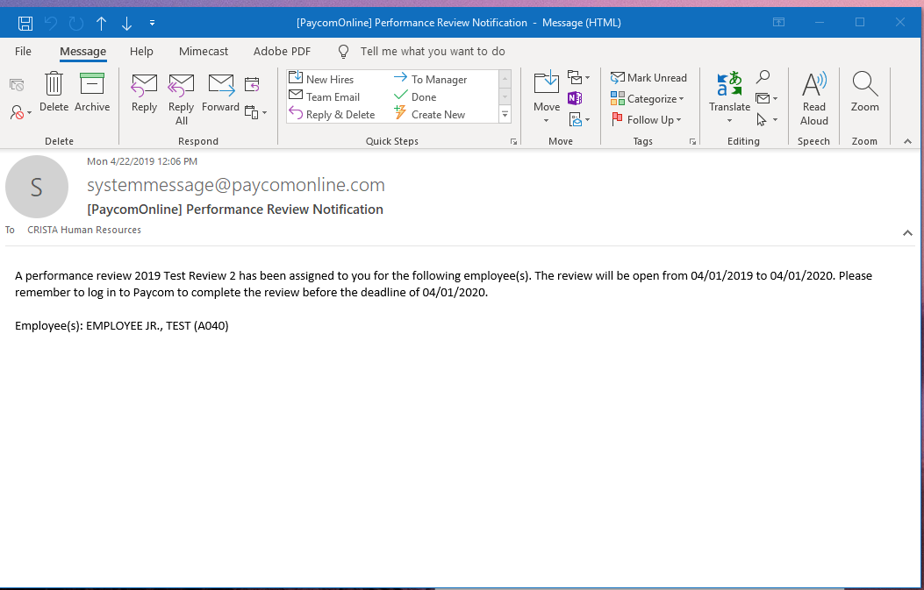

1. **Completing Your Performance Evaluation**
2. Log into your Paycom account and then click on My Performance located under the Performance tile.

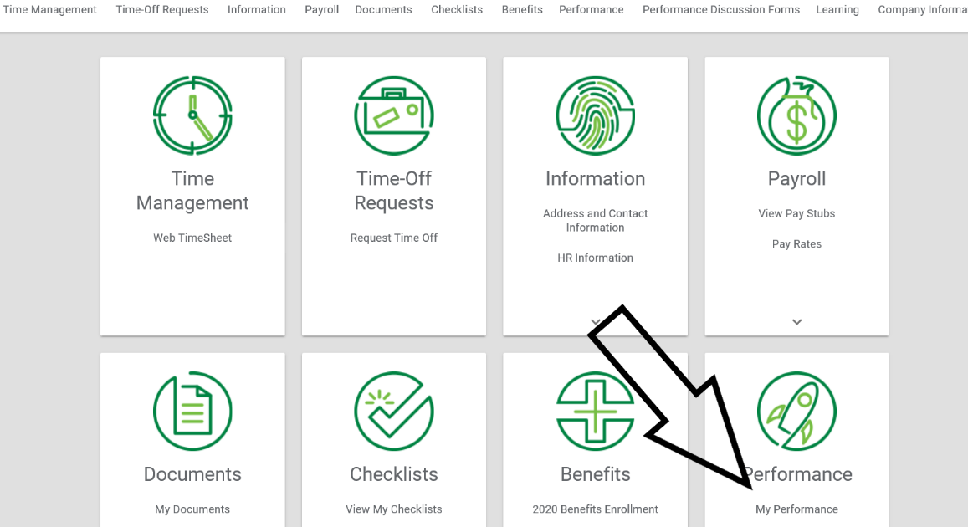

1. Click Reviews from the menu on the left of the screen.
2. Then click on the Active Performance Review and click Start.

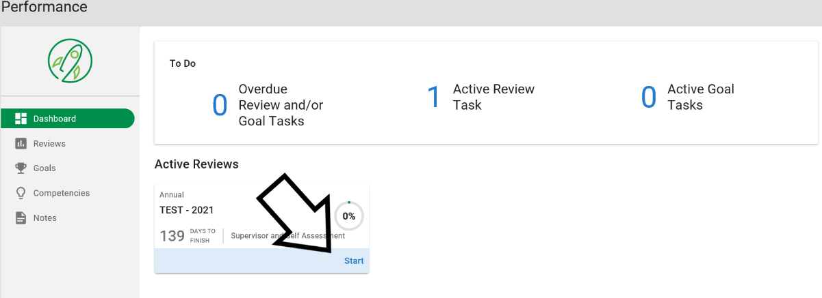

1. You will select a rating for each competency and core value. You will also select a rating for personal goal(s) if they were included in your review.
2. Comments can be added for any competency or core value to explain the selected rating.
3. Type in your name and date, then click Finalize.

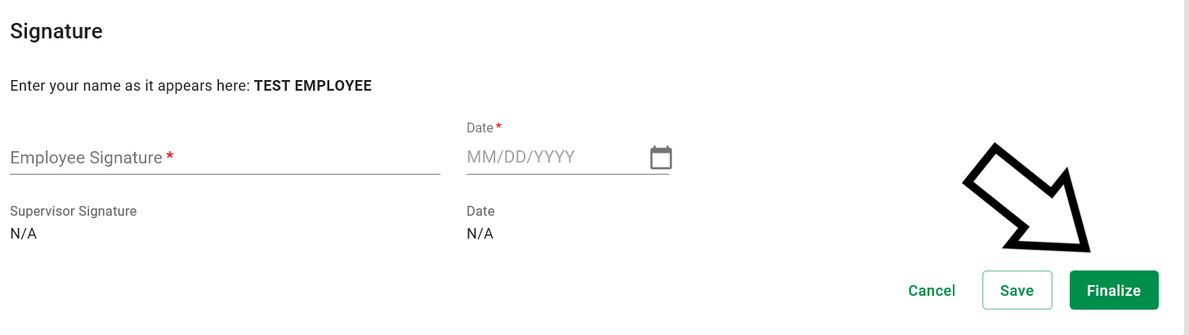

1. **Adding Goals**

Personal goals can also be included in the review process, but this is at your managers discretion.

1. Log into your Paycom account through [www.paycom.com](http://www.paycom.com) (For help with logging in, please contact Heidi Knapp, 206-546-7506).
2. Click on “My Performance”, located under “Performance” (see image below).

1. Then Click “Goals”

1. Click Add Goal. From the Paycom App, the Add Goal button will show in green.

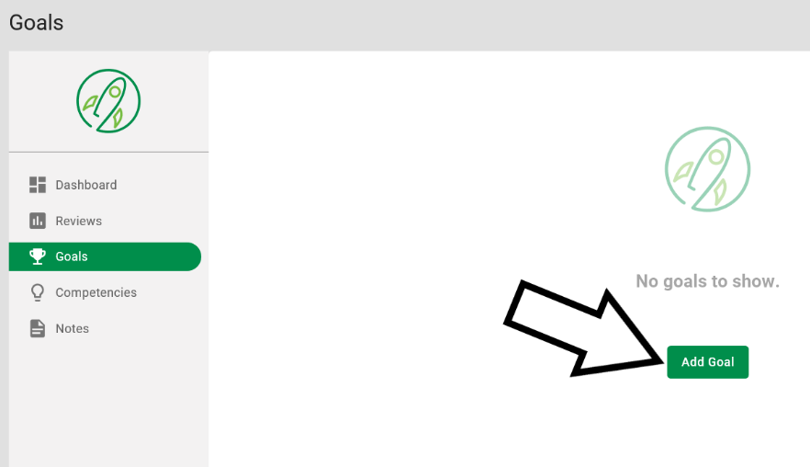

1. Fill in the approved goal information (see examples in table below):
   1. Goal Name (a short title to explain what will be accomplished)
   2. Description (any further details to explain your Goal Name)
   3. Target Completion Date (the date the goal will be completed)
   4. Metric Type and Metric Value (how the goal will be measured)

|  |  |  |  |  |
| --- | --- | --- | --- | --- |
| **Examples** | **Goal Name** | **Metric Type** | **Metric Value** | **Explanation** |
| 1 | Contact 20 new donors each week | Number | 20 | The goal is going to be measured by meeting the number of donor contacts each week |
| 2 | Increase customer satisfaction by 50 percent | Percentage | 50 | The goal is going to be measured by increasing customer satisfaction by 50% |
| 3 | Create process documentation by December 31 | By Date | 12/31 | The goal is going to be measured by whether it is complete within a time frame |
| 4 | Reduce budget by $5,000 | Currency | 5,000 | The goal is going to be measured by a reduction of a specific dollar amount |

1. Then click Add Goal at the bottom of the screen.
2. Repeat these steps until all goals have been added.

**5. Tracking Goals**

If goals were added, you can use the following instructions to track your progress toward goal completion.

1. Log into Paycom, go to Performance Management and click on My Performance.



1. Then click Goals from the menu on the left.
2. This will bring up your goal(s). Click Track next to the goal to record an update.

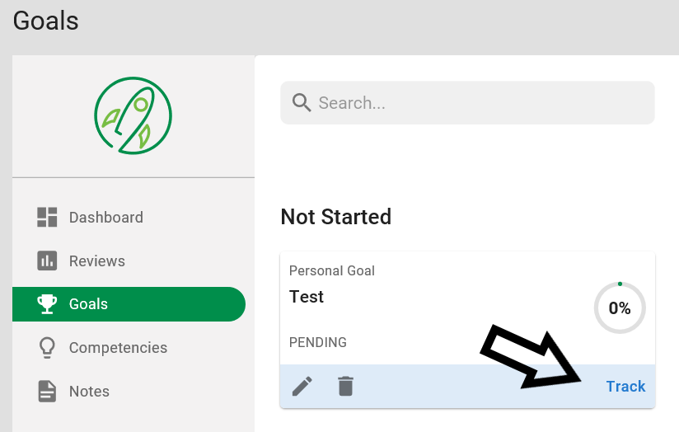

1. Then click the green Add Progress button.

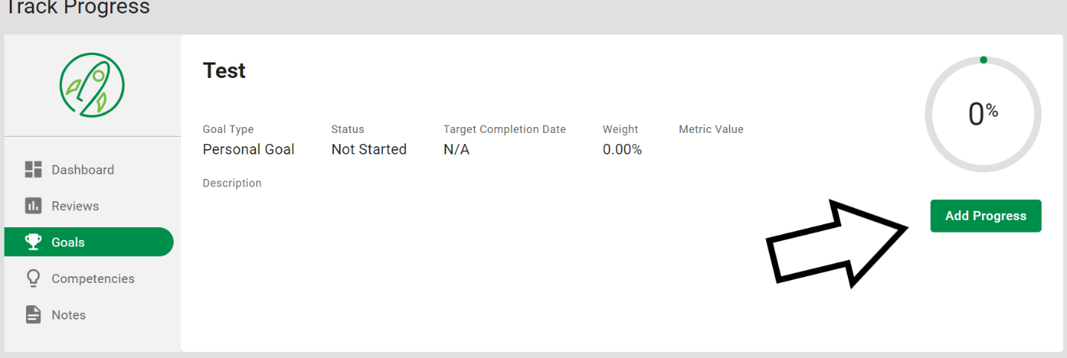

1. Select a status (such as On Track), add a percentage complete and record what has been completed in the comments section.
2. Then click the green Add Progress or Update Progress button at the bottom of the page. You can do this each time you have an update to record.

